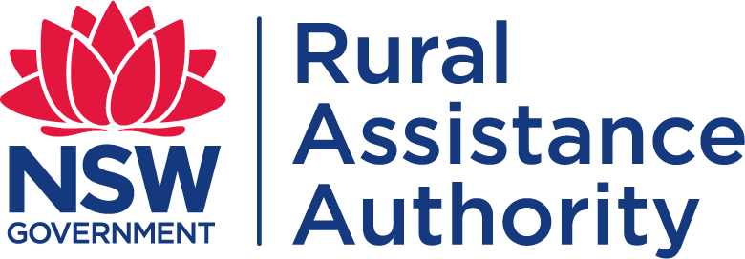
FARM DEBT MEDIATION

APPLICATION FOR INTERNAL REVIEW OF DECISION
OFFICE USE ONLY

FILE #

Farm Debt Mediation Act 1994 (NSW) – Form 10
An application for internal review of a decision under Section 18P(3) the FDM Act must be lodged on this approved form with the Authority within 20 business days of the applicant receiving notice of the decision concerned, or within such longer period as the Authority may allow.

PERSONAL PARTICULARS OF APPLICANT

Surname: | Given name:
Company name: (if applicable)
ABN: | ACN:
Postal address for notices:
Postcode:
Phone number(s):
Email address:

If the applicant is being represented by a solicitor or other person, please provide the particulars of the representative:
Surname: | Given name:
Company name: (if applicable)
ABN: | ACN:
Postal address for notices:
Postcode:
Phone number(s):
Email address:

- DETAILS OF ORIGINAL DECISION
This is an application under section 18P(3) of the FDM Act for internal review of a decision to
  - grant, or to refuse, a prohibition certificate
  - grant, or to refuse, an exemption certificate
  - accredit or reaccredit, or refuse to accredit or reaccredit, a person as a mediator
  - a decision to suspend or cancel the accreditation of a mediator

Date of original decision:
Date applicant notified of decision by email or letter: (whichever is earlier)

Application for Internal Review of Decision Page 1 of 2

Reasons and information to support request for review of original decision:
(may be provided as an attachment)

Within 30 business days of receiving an application for internal review, the Authority will review the original decision, make a decision to confirm, amend or substitute another decision, and give notice to the applicant of the internal review decision.

AUTHORISATION
I/We certify that all the information provided in the whole of this request is true and accurate.
Applicants signature:
Date: / /

PRIVACY
The Authority and NSW Government agencies may use information provided on this form, or by any relevant person, in relation to the administration of the Farm Debt Mediation Act 1994 (NSW). This may include disclosure of information to relevant parties related to your matter.
For more information on your privacy please visit: https://www.nsw.gov.au/departments-and-agencies/department-of-regional-nsw/access-information/privacy-statement

LODGEMENT OF FORMS
Completed forms can be lodged with the NSW Rural Assistance Authority by post, email, facsimile or personal delivery at:

Post: PRIVATE AND CONFIDENTIAL
Farm Debt Mediation Unit
NSW Rural Assistance Authority Locked Bag 23
Orange NSW 2800

Email: farmdebt.mediation@raa.nsw.gov.au

Phone: 1800 678 593 (Toll Free)

Application for Internal Review of Decision Page 2 of 2

