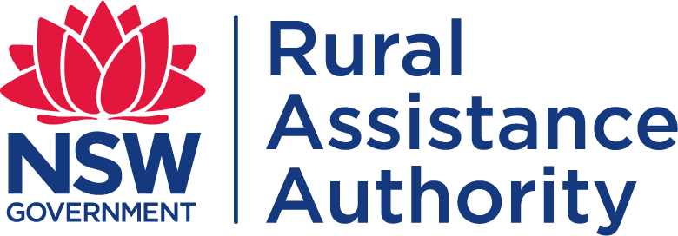
FARM DEBT MEDIATION

REQUEST FOR DOCUMENTS RELEVANT TO FARM DEBT

MEDIATION

Farm Debt Mediation Act 1994 (NSW) – Form 4

This is request for information under the Act from one party to a mediation to another for the purpose of helping to resolve the issues between them. The request is authorised by s 18D2 of the Act. When preparing a summary of the mediation, the mediator will have regard to this request and whether it was reasonable, and whether the information requested was provided within a reasonable period. Any information provided may not be disclosed outside the mediation except as provided in s 18G of the Act.

THE FOLLOWING DOCUMENTS ARE REQUESTED
(farmer or creditor to specify)
☐ | The farmer’s application for a loan & farm mortgage
☐ | The contractual relationship between the farmers and the mortgage, and any variation of the debt or mortgage, including loan or mortgage documents
☐ | Correspondence between the farmer and the mortgagee about changes to the farm business debt or the farm mortgage
☐ | The farmer’s default under the farm mortgage and any action taken by the mortgagee in relation to the default
☐
☐
☐

- CONTACT DETAILS FOR THE PARTIES

FARMER’S CONTACT DETAILS
Farmer’s personal or company name:
ABN: | ACN:
Farmer’s / Guarantor’s name:
ABN: | ACN:
Name of farmer’s authorised representative:
Farmer’s postal address for notices:
Postcode:
Farmers phone number(s): | Farmer’s email address:
Guarantor’s phone number: | Guarantor’s email address:

CREDITOR’S CONTACT DETAILS
Personal or company name of creditor:
ABN: | ACN:
Postal address:
Postcode:
Name of creditor’s contact person:
Creditor’s phone number: | Email address:
It is recommended that the farmer contacts a local Rural Financial Counsellor, accountant and/or solicitor for advice or further information concerning this matter.
PRIVACY
The Authority and NSW Government agencies may use information provided on this form, or by any relevant person, in relation to the administration of the Farm Debt Mediation Act 1994 (NSW). This may include disclosure of information to parties related to the relevant farm debt and/or proposed mediation. Any statistics collected and analysed will be done in such a way as to protect parties’ anonymity.
For more information on your privacy please visit: https://www.nsw.gov.au/departments-and-agencies/department-of-regional-nsw/access-information/privacy-statement

DECLARATION
I acknowledge that I have considered obtaining, or have obtained, independent professional advice before signing this form.

Farmer’s signature(s): Date: / /
OR
Creditor’s signature(s): Date: / /

LODGEMENT OF FORMS

Completed forms can be lodged with the NSW Rural Assistance Authority by post, email, facsimile or personal delivery at:

Post: PRIVATE AND CONFIDENTIAL
Farm Debt Mediation Unit
NSW Rural Assistance Authority Locked Bag 23
Orange NSW 2800

Email: farmdebt.mediation@raa.nsw.gov.au

Phone: 1800 678 593 (Toll Free)

